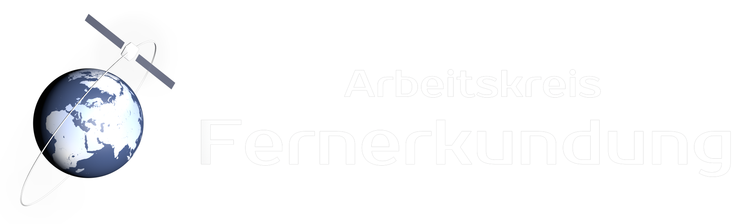
Virtuelles Treffen des Arbeitskreises Fernerkundung am 08. Oktober im Rahmen der #GeoWoche2021

Maxime Musterfrau (University X), Max Mustermann (Institute Y) und Hans Muster (Company Z)

Title of the abstract

Abstract
Please limit to 500 words.

